***Experiment 5 Output***

**Aim:** In this experiment AWS Lambda deployment, execution, and testing are done using **AWS CLI** and **LocalStack**. The runtime image is pulled from **Amazon ECR** via **Docker**. This simulates a serverless environment for function invocation and validation.

***Pulling Amazon ECR for execution***

***Creating Lambda Function***

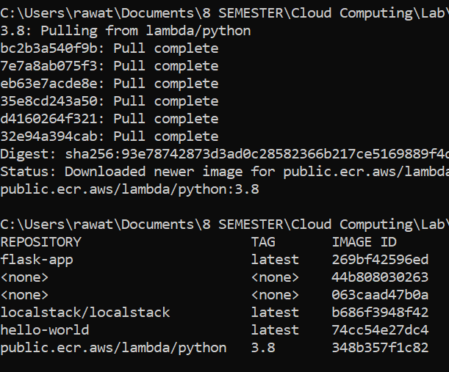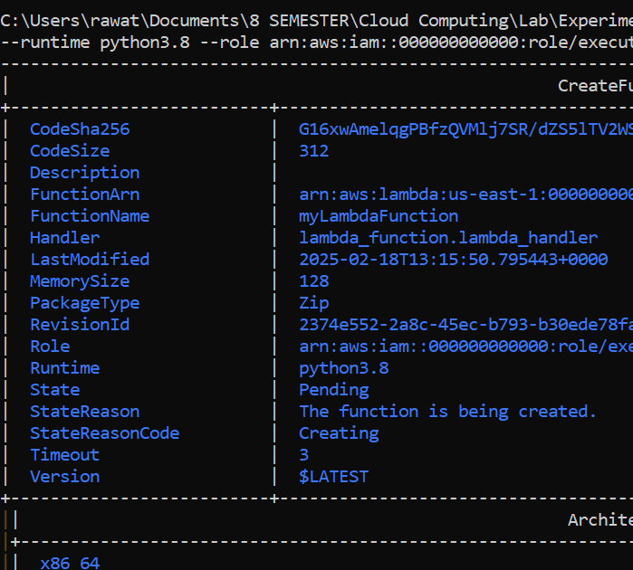

***Fig 2: Docker Pulling and Output Image***

**Fig 1: VPC Setup**

***Listing working Functions***

***Lambda Function invoking with Payload***

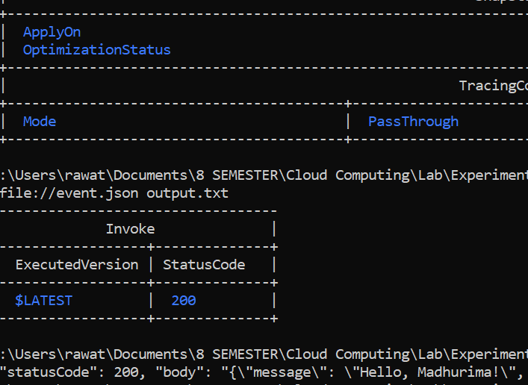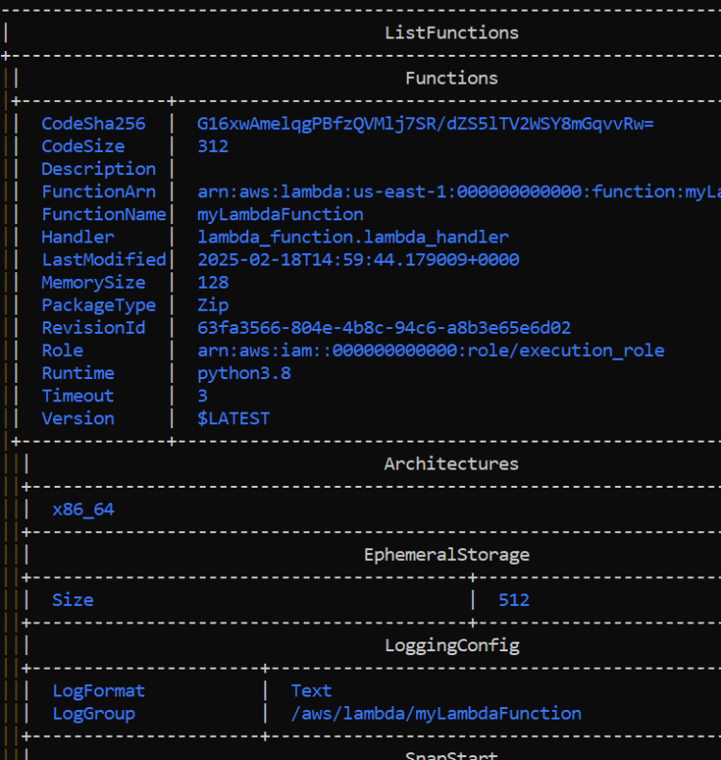

***Fig 3: Lambda working Function***

***Fig 4: Lambda Function Output***